|  |
| --- |
| Medical Project Software Configuration Management Plan |
| CPE 656/658 Software Studio |
| Timothy R. Wilkins  Whit J. Sisulak  Glen L. Riden  James J. Duggan IV |

10/4/2015

# Revision History

|  |  |  |  |
| --- | --- | --- | --- |
| Revision # | Revision Date | **Description of Change** | **Author** |
| 0.1 | 10/4/15 | Initial Draft | J. Duggan |
|  |  |  |  |
|  |  |  |  |
|  |  |  |  |

Table of Contents

Revision History i

1 Introduction 1

1.1 Purpose 1

1.2 Scope 1

1.3 Definitions, Acronyms, and Abbreviations 2

1.4 References 3

2 SCM Management 3

3 SCM Activities 3

3.1 Configuration Items 3

3.2 Configuration Control 3

4 SCM Schedules 6

5 SCM Resources 8

5.1 Tools 8

5.2 Training 8

6 SCM Plan Maintenance 8

Software Configuration Plan

# Introduction

## Purpose

The purpose of this document is to define the software configuration plan for the UAHealth software projects. This document should be used as a process artifact that defines how to manage project documentation and the system’s software. The intended audience for this document includes system developers, testers, customers, and any other stakeholders.

## Scope

In the sections below an overview will be given for the two pieces of software that will be required to fulfill the requirements proposed by our customer. Next there will be a brief overview of what will be required in the software configuration plan.

### Data Collection

The data collection portion of this project will consist of the following. There are two different medical devices to be used for this project that record various types of data. The data provided by these devices consists of different file formats, and the data is different from device to device. The software will have to determine the contents of each file and how to process them. Due to how long data transfers take to download the data from a device, there may be a need to convert the data from a binary format to another format in order to speed up the process of getting data off the device. The software needs to able to take in files provided by the medical devices and be able to translate them in a way where they can be stored in a database. The software needs to run in the background of a PC and wait for files that need to be processed. The software will have to interact with a database to insert the data that has been processed in order for the data to be stored for later analysis. The software should allow for some basic configuration such as designating a folder on the PC to be a listener. Files moved or copied into this folder will be processed by the software when they are added. The software should have the ability to process multiple files if more than one is placed into the processing folder at a time.

### Data Analysis

Data analysis software needs to be created to analyze the data that is captured from the data collection tool mentioned above. This piece of software will be a separate stand-alone web application. The software needs to perform data analysis over different intervals of time such as one week, one month, etc. There will need to be some way to manage user access to the various medical data that has been inserted into the database that this software will access. Below are some proposed data analysis ideas that can be incorporated into the project.

* Simple Moving Average
* Data correlation discovery between the multiple devices.
* Possibly determine when an individual moves from walking to running or simply being able to identify the activities that were being performed while the data was being captured.

The data analysis possibilities will likely not fully be realized until the project team understands the different types of data that are available. Also, there will need to be collaboration with the customer for additions or changes to the data measurements provided by this software. The web application will have to have different levels of user access which will be defined later in this document.

### Software Configuration Management Plan Overview

The Software Configuration Management Plan (SCM) will consist of the following items.

* Documentation Management
* Software Management
* Release Process
* Configuration Management Role Responsibilities

Documentation management will describe how the document artifacts will be controlled, stored, and distributed to the various stakeholders involved in this project. Software management will describe how and where the software for this project will be stored and accessed for releases. It will also describe a branching strategy that will be put in place during development. The release process will explain the different types of releases that can occur. There will be two types of releases: formal and informal. The configuration management roles will also be defined in this document.

## Definitions, Acronyms, and Abbreviations

|  |  |
| --- | --- |
| *SCM* | Software Configuration Management Plan |
| *SRS* | Software Requirements Specifications |
| *SDD* | Software Design Document |
| *SDP* | Software Development Plan |
| *STP* | Software Test Plan |
| *ROM* | Rough Order Estimate |

## References

IEEE Std 828-1998, IEEE Standard for Software Configuration Management Plans

Git-Flow Branching Model (http://nvie.com/posts/a-successful-git-branching-model/)

Atlassian Branching Tutorials (https://www.atlassian.com/git/tutorials/comparing-workflows/gitflow-workflow)

# SCM Management

# SCM Activities

## Configuration Items

### SRS – Microsoft Word document

### SDD – Microsoft Word document

### SDP – Microsoft Word document

### STP – Microsoft Word document

### SCM – Microsoft Word document

### ROM - Microsoft Word document

### Data Collection Software Source Code – Source code files that include the following file types: .cs, .sln, and .csprog.

### Data Analysis Web Application Source Code – Source code files that include the following file types: .cs, .cshtml, .js, .config, .sln, and .csproj.

## Configuration Control

The configuration items listed in section 3.1 will be controlled using both the UAH Canvas web application and GitHub. There will be two types of releases that each can apply to each configuration item. The first is an informal release. An informal release occurs every week on during which document updates are submitted to the various stakeholders on the project. The second type of release is a formal release. This release will occur at the culmination of the project period when all the documents and source code are turned over to the customer.

### Informal Release Process

#### Documentation

Each member of the team will be responsible for uploading any documents that they have generated or modified to either Canvas or GitHub. Canvas discussions are used to notify the other members of the team of new or updated documents and where they can be found. The documents are then reviewed by the members of the team and any comments or changes are provided. If there are no required changes, then the changes are merged into the document by the team member that has authored that document. In the case that the document author is not available the team member that made the change is responsible for modifying the document with the new changes. At this point the document should be updated in the GitHub master branch. This is where the informal releases will be pulled for submission to a stakeholder. Each document shall have a revision history section in order to keep track of changes made to each document. The revision history table shall contain a version number, a summary of the changes made to the document, and the author of the changes.

#### Source Code

The configuration control plan for source code will be modeled after Vincent Driessen’s branching model which has also known as git-flow. The process involves maintaining two branches master and develop. The master branch will contain the different software releases that occur during the project lifetime. The develop branch is the main development branch that contains all the new features and/or improvements that will go into the next release. When a new feature or an improvement needs to be implemented a new feature branch will be created. Upon the completion of the feature or improvement the branch will be merged into the develop branch and then deleted. Before making a release the develop branch will be merged into a new release branch that is meant for final testing before the release. Once testing is completed any and all changes made in the release branch are merged back into both the master and develop branches and a new tag is created on the master branch that will be represented by the current version number of the software. See the references section for links to more information about the git-flow process.

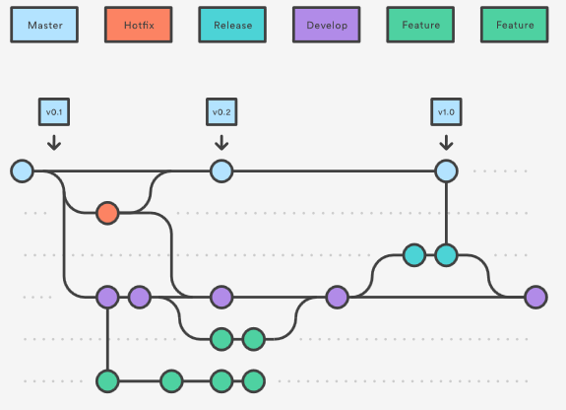

Figure 1 – Git-Flow Atlassian Branching Tutorial

### Formal Release Process

### Version Numbering

#### Documentation

Version numbers will constructed from a major and minor number. These will be combined with periods between each in the following fashion:

**X.X** (major.minor)

**Major Number**: Major number is incremented every time the document is considered to be a final project.

**Minor Number**: Minor number is incremented every time an edit is made to the document leading up to the final project.

#### Source Code

Version numbers will constructed from a system, major, minor, hotfix, and build number. These will be combined with periods between each in the following fashion:

**X.X.X.X.X** (system.major.minor.hotfix.build)

**System Number**: System number will rarely change as this would mean that the entire software product had been recreated or the software changed so radically that it could be considered a new product. This number will only increment after a formal release to the customer.

**Major Number**: Major number is incremented for each release completed in the git-flow process. This will occur when the all the new features and improvements in the develop branch are merged into the master branch.

**Minor Number**: Minor number is incremented every time a feature branch is merged into the develop branch.

**Hotfix Number**: Hotfix number is incremented only if a critical bug is identified and a fix needs to be sent to a user prior to the next release and will include the fix for this bug.

**Build Number**: Build number is used to determine what build version of the software is being used. Mostly, it is used to see what build is on a test server during the testing and development stages.

# SCM Schedules

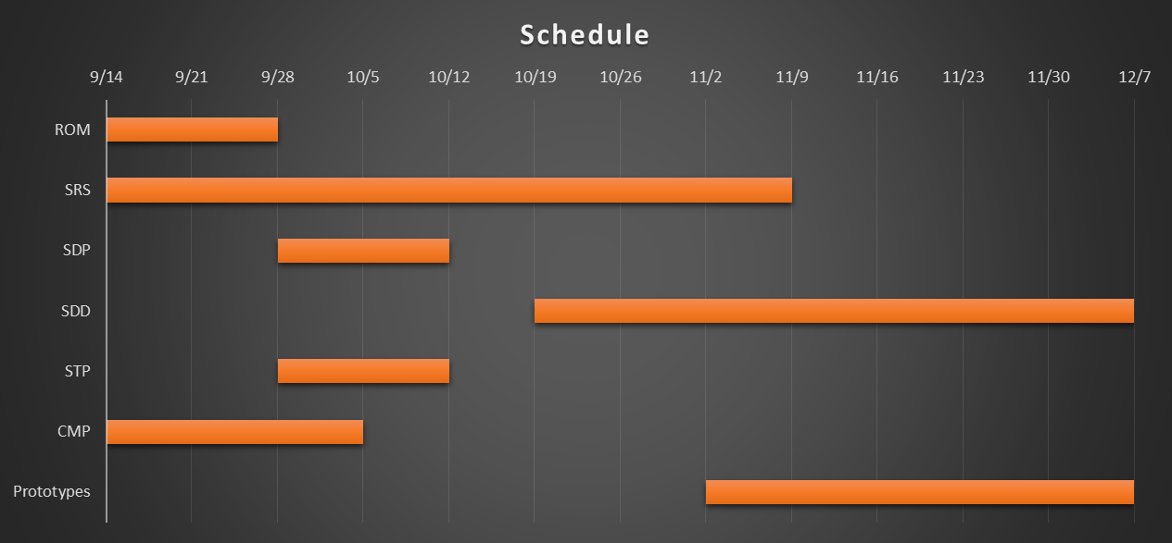

Figure 2: SCM Schedule

The preceding diagram illustrates the tentative schedule for this project. The overall goal is to complete the initial version 1.0 by the dates above. During the identified schedule times each document may go through several minor or major revisions before being finalized. After December 7th all documentation will be considered frozen for the duration of the project term and not changed until after a formal release has occurred and new changes have been proposed by the customer. The dates above are not firm dates but have been set to help establish a base line for configuration item initial releases. The only scheduling requirement that must be met is that all configuration items be released by December 7, 2015.

The schedule does not include the following details. The SDD is blocked by the completion of the SRS. This means that the SDD cannot be completed without a complete SRS. Work on the SDD document however can begin before the SRS is completed The prototype is meant to be two working pieces of software with limited functionality based on the requirements laid out in the SRS and the design completed in the SDD. Upon completing the prototypes, and initial beta version of the software project shall be available.

The planned formal release does not have an exact date as this point but is planned tentatively for the end of April 2016. At this time the project will be considered completed and all documentation and source code will go through a formal release process and be delivered to the customer.

# SCM Resources

## Tools

* Visual Studio
* Git Plugin for Visual Studio
* Git Desktop Application
* UAH Canvas
* Microsoft Word

## Training

There may be training required for member of the team that have not used any of the tools mentioned in the previous section. In the event that training is required a group meeting will be held to provide cross training to any member of the team that needs training in one of the areas listed above. There may also be online tutorials that may be referenced for additional training.

Training will either be provided face-to-face or through an online video conference tool. Screen sharing will be required to adequately facilitate the training exercise. The trainer will also have to have a working microphone allowing for verbal communication in order for the training to be more efficient.

Upon completion of a new software release any new features or major improvements will require cross training. The team member that developed the feature or improvement shall provide training to the other members of the team prior to release of the feature or improvement.

# SCM Plan Maintenance

Configuration plan maintenance will be performed/reviewed at the start of each project phase (requirements, design, implementation and testing). If the CM plan is changed at the start of a project phase, the plan will be distributed to the team. The updated CM plan will include a history of the changes made, who is responsible for monitoring the plan, how changes to the plan will be approved, and how the changes will be made and distributed.